**Practical 6:**

**Aim: Implement the k-means clustering algorithm.**

**Solution:**

**Code: Creating dataset for kmeans**

import numpy as np

import math

import pandas as pd

import matplotlib.pyplot as plt

import random

np.random.seed(1)

def circulo(num_datos=100, R=1, minimo=0, maximo=1, center_x=0, center_y=0):

    pi = math.pi

    r = R * np.sqrt(np.random.uniform(minimo, maximo, size=num_datos))

    theta = np.random.uniform(minimo, maximo, size=num_datos) * 2 * pi

    x = center_x + np.cos(theta) * r

    y = center_y + np.sin(theta) * r

    x = np.round(x, 3)

    y = np.round(y, 3)

    df = np.column_stack([x, y])

    df = pd.DataFrame(df)

    df.columns = ['x', 'y']

    return(df)

# Create data

datos_1 = circulo(num_datos=20, R=10, center_x=5, center_y=30)

datos_2 = circulo(num_datos=20, R=10, center_x=20, center_y=10)

datos_3 = circulo(num_datos=20, R=10, center_x=50, center_y=50)

data = pd.concat([datos_1, datos_2, datos_3], axis=0)

data.head()

plt.scatter(datos_1['x'], datos_1['y'], c='b', s=1.0)

plt.scatter(datos_2['x'], datos_2['y'], c='r', s=1.0)

plt.scatter(datos_3['x'], datos_3['y'], c='g', s=1.0)

plt.title('Data Set Visualization')

**Output**

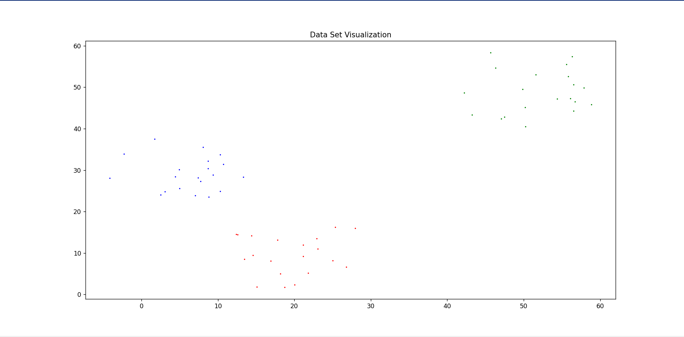

**Code:**

**2. Implementation of kmeans from scratch**

# implements kmeans from scratch

def kmeans(df, k, data_num):

    # chooses different random points from dataset for initial clusters

    x_list, y_list = generate_random_points(df, k)

    df_copy = df.copy()  # copying data set

    check = True

    objective_function = []  # stores all object function values in each iteration

    iter = 0  # number of iteration

    points_colors = {}  # colors for the clusters

    while (check):

        i = 0

        # calculates distance for every point according to its cluster centroid

        df_copy, total_points, obj_func = calculate_dist(

            df_copy, x_list, y_list, k)

        # sum of objective function values

        total_obf = 0

        for obj in obj_func.values():

            total_obf += obj

        # adds current objective function value to the list

        objective_function.append(total_obf)

        # stops the while loop when objective function starts to converge

        if abs(objective_function[iter - 1] - objective_function[iter]) < 0.01 and iter >= 1:

            check = False

        # calculates new values for centroids

        for coordinates in total_points.values():

            new_x, new_y = calculate_mean(coordinates)

            x_list[i] = new_x

            y_list[i] = new_y

            i += 1

        # plots the initial cluster centers

        if iter == 0:

            points_colors = initial_cluster_centers_plot(

                df_copy, x_list, y_list, k, data_num)

        iter += 1

    final_cluster_centers_plot(

        df_copy, x_list, y_list, points_colors, iter, objective_function[-1])  # plots final

# calculates euclid distance for two points

def euclid_calculator(x1, y1, x2, y2):

    # euclid distance formula

    distance = np.sqrt(np.square(abs(x1 - x2)) + np.square(abs(y1 - y2)))

    return distance

def calculate_dist(df_dist, x_list, y_list, k):

    obj_func = {}  # stores object functions for each distances

    total_points = {}  # stores all data points for each cluster centroids

    # creates points with names according to number of k

    for x in range(1, k + 1):

        name = 'point_'

        obj_func[name + str(x)] = 0

        total_points[name + str(x)] = []

    for index, row in df_dist.iterrows():

        points_distance = {}

        for x in range(1, k+1):

            name = 'point_'

            points_distance[name + str(x)] = 0

        for x, y, point in zip(x_list, y_list, points_distance.keys()):

            # calculates distance for determine point is close to which center

            distance = euclid_calculator(x, y, row['x'], row['y'])

            # stores points with distances

            df_dist.loc[index, point] = distance

            points_distance[point] = distance

        # sorts for finding every point close to which center

        sorted_dist = sorted(points_distance.items(), key=lambda kv: kv[1])

        point = [row['x'], row['y']]

        point_type = sorted_dist[0][0]

        obj_func[point_type] += np.square(sorted_dist[0][1])

        df_dist.loc[index, 'point_type'] = point_type

        total_points[point_type].append(tuple(point))

    return df_dist, total_points, obj_func

# calculates min x and y values for finding the new centroids

def calculate_mean(dist_list):

    x_total = 0

    y_total = 0

    for item in dist_list:

        x_total += item[0]

        y_total += item[1]

    mean_x = x_total / len(dist_list)

    mean_y = y_total / len(dist_list)

    return mean_x, mean_y

# calculates sum of all distances

def total_dist(dist):

    dist_sum = 0

    for item in dist:

        dist_sum += item

    return dist_sum

# visualizing scatter plot version of data

def scatter_plot(plotted_df):

    fig, ax = plt.subplots()

    # selecting x and y axises without labels

    ax.scatter(plotted_df['x'], plotted_df['y'], c=plotted_df['class'])

    plt.xlabel('x')  # entering name for x axis

    plt.ylabel('y')  # entering name for y axis

    plt.title("Dataset")  # entering a title for plot

    plt.show()

# plots the initial cluster centers

def initial_cluster_centers_plot(initial_df, x_list, y_list, k, data_num):

    fig, ax = plt.subplots()

    # defining colors for each clustered points at the beginning according to k number

    points_colors = {'point_1': 'b', 'point_2': 'r', 'point_3': 'g', 'point_4': 'y',

                     'point_5': 'c', 'point_6': 'm', 'point_7': 'k', 'point_8': 'w'}

    # selecting x and y axises with point type of each row

    ax.scatter(initial_df['x'], initial_df['y'],

               c=initial_df['point_type'].map(points_colors), s=1.0)

    # draws the new centroids according to mean values

    for x, y in zip(x_list, y_list):

        plt.scatter(x, y, c='black', s=10)

    plt.xlabel('x \n Initial Cluster Centers \n Dataset=' +

               str(data_num)+'\n k='+str(k))

    plt.ylabel('y')

    plt.title("k-Means")

    plt.show()

    return points_colors

# plots the final cluster centers

def final_cluster_centers_plot(final_df, x_list, y_list, points_colors, iter_num, final_obf):

    fig, ax = plt.subplots()

    ax.scatter(final_df['x'], final_df['y'],

               c=final_df['point_type'].map(points_colors), s=1.0)

    for x, y in zip(x_list, y_list):

        plt.scatter(x, y, c='black', s=10)

    plt.xlabel('Final Cluster Centers\n Iteration Count=' +

               str(iter_num) + '\n Objective Function Value:' + str(final_obf))

    plt.ylabel('y')

    plt.title("k-Means")

    plt.show()

# generates random points for initial cluster centroids

def generate_random_points(dataset, k):

    rand_x, rand_y = [], []

    random_points = random.sample(range(1, len(dataset) - 1), k)

    for rand_index in random_points:

        rand_x.append(dataset.iloc[rand_index][0])

        rand_y.append(dataset.iloc[rand_index][1])

    return rand_x, rand_y

k = 3

data_num = 1

# Create object of KMeans class

km = kmeans(data, k, data_num)

**Output:**

